Pump Controller

# Description

A device which can monitor and switch household water pumps remotely.

This version forgoes din rail mounted components including the PCB enclosure and the contactor in favor of a chassis mounted heavy contact relay and a standoff mounted PCB. It also switches to an open frame AC/DC module decreasing the price.

# Constraints

Power: Mains voltage 100-240V

Dimensions: Must fit within a typical junction box, preferably a 10x10cm box

# Features

* Monitor the on/off status and current consumption
* Switch the pump off if desired.
* Indicate if the pump is running dry.
* Wireless connectivity
* Matter optional

# Block Diagram

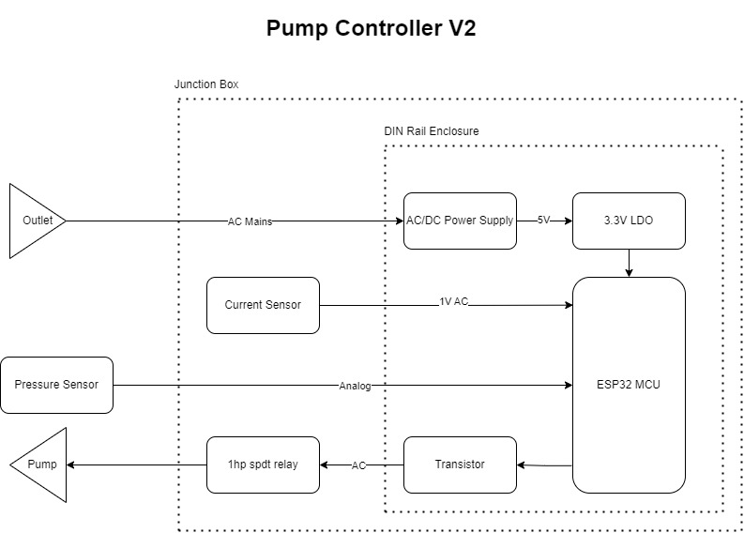

# Future Improvements

* Utilize 3.81mm or 5.08mm plug-in terminal blocks instead of spring clamp blocks for AC power.
* Utilize 3.81mm plug-in terminal blocks instead of JST connectors.
* Avoid 2.0mm connectors in the future and stick with 2.54mm to enable Dupont cables.
* Replace TC2050 with custom 2x5 2.54mm ISP footprint to utilize testing clamp.
* Replace UART connector with 1x4 2.54mm connector footprint for testing clamp.
* Use Hi-link HLK-PM01 for this application.
* Design a custom enclosure for the PCB and redesign the whole PCB.

# Components

MCU: ESP32-C3-WROOM-02U-N4

## AC/DC Power Supply: PBO-5C-5 2.8$ OR LS05-13B05R3 OR 5ACFEW_05S3

Fuse Holder: 56000001019 or 56000001009

Fuse: 39212000000 or 0034.6618

MOV: B72214S0351K101

Resistor: FMP200JR-52-12R

Input Inductor: RLB9012-472KL

Capacitor: B43821F5226M000

CY: CL31B102KHFNFNE

Output Cap: A750EQ477M1CAAE015

Output inductor: LSXBD6060WHL4R7M

Output Cap 2: ESL107M035AE3AA

TVS: SMBJ7.0CA-13-F

CAP 3: CL10B105KO8NNNC

## 3.3V LDO: AP2112K-3.3TRG1

Zmct102 (pcb mount)

Terminals: WJ142V-5.08-2P

JST Connector: B3B-XH-2(LF)(SN)

Pressure Sensor: Seeed 114991178 or equivalent.

Terminal Block: XY118-5.0-2P

ADC?

Relay: J115F21C5VDCS_9 or az2100-1ce-5def or SLC-5VDC-SL-C

Flyback Diode: 1N4007FL

Transistor: DMG2302U-7

Box: 10x10cm CCTV box

# Power Budget

|  |  |  |  |  |
| --- | --- | --- | --- | --- |
| Component | Voltage/s | Current/s | Power | Type |
| PBO-5C-5 | 5V | 1A | 5W | Source |
| AP2112K-3.3TRG1 | 3.3V | 0.6A | 1.98 | Source |
| ESP32-C3-WROOM-02U-N4 | 3.3V | 0.35A | 1.15W | Sink |
| 114991178 | 5 | 0.01 | 0.05W | Sink |
| J115F31CH5VDCS61.5U | 5 | 0.3 | 1.5W | Sink |
|  |  |  |  |  |
| Total | 1.3W | | |  |

*Some ICs have multiple voltage rails with different voltage levels.